**Project Planning Phase**

**Project Planning Template (Product Backlog, Sprint Planning, Stories, Story points)**

|  |  |
| --- | --- |
| Date | 06 July 2024 |
| Team ID | SWTID1720010842 |
| Project Name | Book a Doctor |
| Maximum Marks | 4 Marks |

**Product Backlog, Sprint Schedule, and Estimation (2 Marks)**

| **Sprint** | **Functional Requirement (Epic)** | **User Story Number** | **User Story / Task** | **Story Points** | **Priority** | **Team Members** |
| --- | --- | --- | --- | --- | --- | --- |
| Sprint-1 | Database Architecture | USN-1 | As a DBA, I need to design the database schema to support the doctor appointment features such as patient records, doctor schedules, and appointment bookings. | 3 | High | Swatie |
| Sprint-2 | Database Setup | USN-2 | As a DBA, I need to deploy the designed database schema to the development server and ensure its accessibility. | 2 | Medium | Jai |
| Sprint-3 | Backend Integration | USN-3 | As a backend developer, I need to integrate the database with the backend application to enable data storage and retrieval for doctor appointments. | 2 | Low | Swatie,Jai |
| Sprint-4 | Frontend Development | USN-4 | As a frontend developer, I need to create the user interface for patients to book appointments and doctors to manage their schedules. | 4 | High | Nikhita,Kavya |
| Sprint-5 | System Testing | USN-5 | As a QA tester, I need to conduct thorough testing of the entire system, including database operations, backend functionalities, and frontend user interactions to ensure everything works as expected. | 3 | High | Nikhita,Kavya |

**Project Tracker, Velocity & Burndown Chart: (2 Marks)**

| **Sprint** | **Total Story Points** | **Duration** | **Sprint Start Date** | **Sprint End Date (Planned)** | **Story Points Completed (as on Planned End Date)** | **Sprint Release Date (Actual)** |
| --- | --- | --- | --- | --- | --- | --- |
| Sprint-1 | 20 | 2 Day | 07 July 2024 | 09 July 2024 |  |  |
| Sprint-2 | 20 | 2 Day | 09 July 2024 | 11 July 2024 |  |  |
| Sprint-3 | 20 | 2 Day | 11 July 2024 | 13 July 2024 |  |  |
| Sprint-4 | 20 | 3 Days | 07 July 2024 | 10 July 2024 |  |  |
| Sprint-5 | 20 | 3 Days | 10 July 2024 | 13 July 2024 |  |  |

**Velocity:**

Imagine we have a 10-day sprint duration, and the velocity of the team is 20 (points per sprint). Let’s calculate the team’s average velocity (AV) per iteration unit (story points per day)

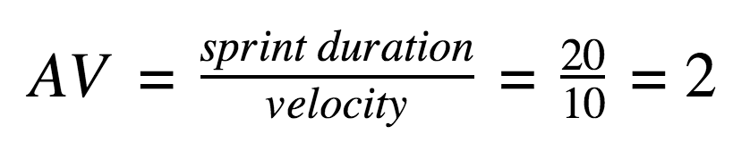

**Burndown Chart:**

A burndown chart is a graphical representation of work left to do versus time. It is often used in agile[software development](https://www.visual-paradigm.com/scrum/what-is-agile-software-development/) methodologies such as [Scrum](https://www.visual-paradigm.com/scrum/scrum-in-3-minutes/). However, burn down charts can be applied to any project containing measurable progress over time.

[**https://www.visual-paradigm.com/scrum/scrum-burndown-chart/**](https://www.visual-paradigm.com/scrum/scrum-burndown-chart/)

[**https://www.atlassian.com/agile/tutorials/burndown-charts**](https://www.atlassian.com/agile/tutorials/burndown-charts)

**Reference:**

[**https://www.atlassian.com/agile/project-management**](https://www.atlassian.com/agile/project-management)

[**https://www.atlassian.com/agile/tutorials/how-to-do-scrum-with-jira-software**](https://www.atlassian.com/agile/tutorials/how-to-do-scrum-with-jira-software)

[**https://www.atlassian.com/agile/tutorials/epics**](https://www.atlassian.com/agile/tutorials/epics)

[**https://www.atlassian.com/agile/tutorials/sprints**](https://www.atlassian.com/agile/tutorials/sprints)

[**https://www.atlassian.com/agile/project-management/estimation**](https://www.atlassian.com/agile/project-management/estimation)

[**https://www.atlassian.com/agile/tutorials/burndown-charts**](https://www.atlassian.com/agile/tutorials/burndown-charts)